Task 6: To create this.

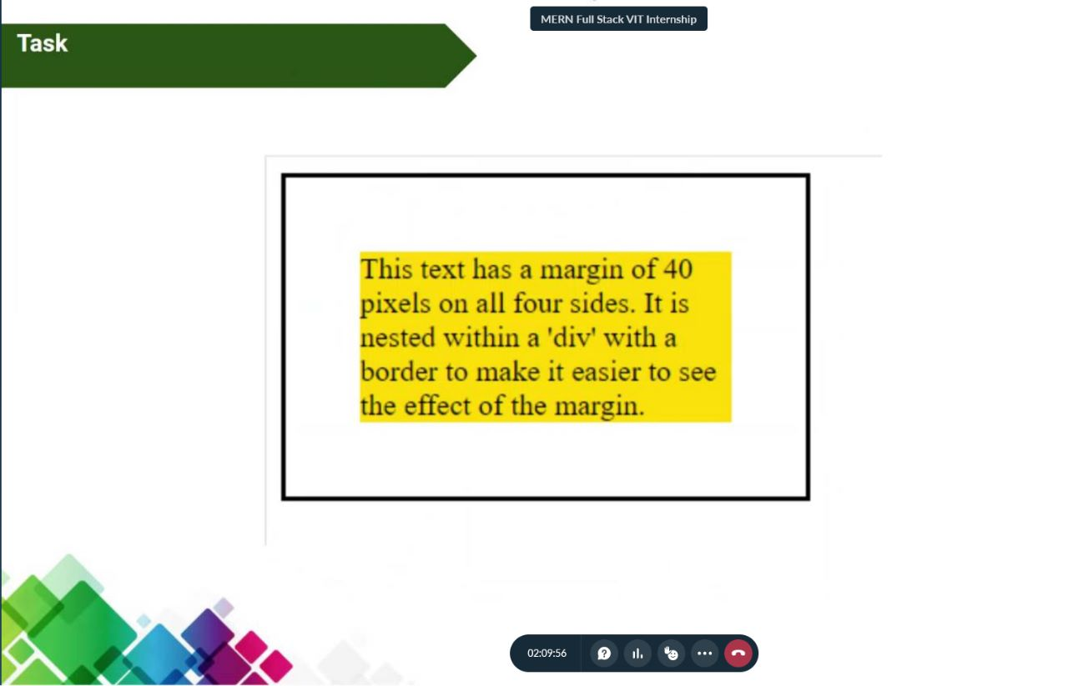

HTML code:

<html lang="en">

  <head>

    <link rel="stylesheet" href="para.css" />

    <meta charset="UTF-8" />

    <meta http-equiv="X-UA-Compatible" content="IE=edge" />

    <meta name="viewport" content="width=device-width, initial-scale=1.0" />

    <title>Paragraph</title>

  </head>

  <body>

    <br />Paragraph - 20BCE2096 <br /><br />

    <div class="custom-div">

      <p class="custom-paragraph">

        Lorem ipsum dolor sit amet consectetur adipisicing elit. Autem omnis

        repellat maiores quasi. Maiores veritatis distinctio ullam expedita

        accusantium dolores perferendis tempora quaerat suscipit, sed amet, ad

        voluptates in harum?

      </p>

    </div>

  </body>

</html>

CSS code:

\* {

  box-sizing: border-box;

  margin: 10px;

}

.custom-div {

  border: 1px solid black;

}

.custom-paragraph {

  background-color: yellow;

  margin: 40px;

}

Output:

